

**SCHOOL OF BUSINESS AND ECONOMICS**

**DEPARTMENT OF BUSINESS TECHNOLOGY**

**COURSES:**

**SYSTEM ENGINEERING,DATABASE AND JAVA PROGRAMMING**

**Student name: Nyangoma Annet Mukabarisa**

**Reg No:222001557**

**Submitted to: Dr. BUGINGO Emmanuel**

**Date: 09 MARCH 2024**

# **SYSTEM ENGINEERING**

# List of Figigures

# List of tables

Table of Contents

List of Figures 2

List of tables 2

Introduction 4

TOPIC TALENT MANAGEMENT SYSTEM. 5

Statement of the problem 5

Description of the existing system 5

Problems of the current system 5

How the proposed system will work? 6

Describe other alternatives 7

Software requirement 8

User Requirements 8

Functional requirement 9

Non-function requirement 9

Portability requirement 11

Reliability requirement 11

Usability requirement 12

Space requirement 14

Organization requirement 15

Implementation requirement 16

External environment requirement 17

Privacy requirement 18

Safety requirement 19

System requirements 21

Minimum End-user Hardware Requirements 21

Minimum End-user Software Requirements 21

Software specifications 21

DATA FLOW DIAGRAM (LEVEL 0, LEVEL 1**)** 22

DFD LEVEL 0 22

DFD LEVEL 1 23

Feasibility study 23

Technical Feasibility 24

Financial Feasibility 25

Market Feasibility 25

Economic Feasibility 26

Legal and Regulatory Feasibility 27

Operational Feasibility 28

Description of the selected Process Model 28

Cause of your selection 30

Conclusion 31

References 33

# Introduction

Organizations from a wide range of industries understand the critical importance of attracting, developing, and keeping top talent in today's fiercely competitive business environment. Effective talent management has become a strategic necessity for businesses looking to gain a competitive edge. As a result, talent management systems have been widely adopted as effective tools for enhancing the entire talent lifecycle within an organization.

An array of integrated processes, technologies, and strategies known as a talent management system are used to find, attract, evaluate, develop, and keep hold of high-potential employees. It provides a thorough method for hiring people, managing performance, planning for succession, fostering learning and growth, and advancing one's career. These essential HR processes can be streamlined into a single system; organizations can create a talent-centric culture that aligns with their strategic objectives.

Enhancing the effectiveness and efficiency of talent acquisition is one of the main advantages of a talent management system. Organizations can find the best candidates for key roles by utilizing cutting-edge recruitment technologies and analytics, which cuts down on the time and expense involved with conventional recruitment techniques.

Additionally, employee engagement and ongoing professional development are made possible by talent management systems. Organizations can synchronize individual goals with overall objectives, give regular feedback, and promote a culture of ongoing learning and development through effective performance management procedures.

In conclusion, a well-designed talent management system enables organizations to develop a pipeline of high-performing people, foster leadership qualities, and increase workforce productivity. It gives organizations the ability to proactively close talent gaps, enhance employee engagement and retention, and ultimately boost business success in a market that is getting more and more competitive on a global scale

# TOPIC TALENT MANAGEMENT SYSTEM.

## Statement of the problem

In these days there is no online platform like apps and website where children and others who have talents can show up their talents it only done through competitions only where all are required to come and show up their talents by competing with others and sometimes there people who do not get that chance to attend the competitions, there are some of the problems that have to be solved by the new system like limited openings diverse to the talents, inclusivity in the talent show competition, weakened overall experience of the participants and audience. I found that it is necessary that we can bring a new platform which is online platform like apps and website that will be used by those children with talents to apply by using that platform and show up their talents as we do for jobs etc.

### Description of the existing system

A talent show competition is an event or series where individuals or groups showcase their unique skills and talents in front of a live audience and a panel of judges. These competitions provide a platform for participants to display their abilities in various artistic or performance-based disciplines, such as singing, dancing, acting, comedy, magic, or any other form of entertainment.

Talent show competitions typically follow a structured format, with multiple rounds or episodes leading up to a final winner or winners. Contestants are often required to audition before being selected to participate in the main competition. The auditions serve as a preliminary screening process, where judges or producers evaluate the potential talent and choose the most promising performers to move forward.

During the competition, participants showcase their talents through prepared acts or performances, which can range from individual acts to group performances. Contestants are usually given a limited amount of time to present their skills and leave a lasting impression on the judges and the audience. Judges play a critical role in talent show competitions, providing feedback, critiques, and scores to evaluate the performances. Overall, talent show competitions offer a platform for aspiring performers to gain exposure, recognition, and potentially launch a career in the entertainment industry. They provide a stage for individuals to demonstrate their skills, pursue their passion, and compete for prizes or opportunities that can propel them further in their artistic endeavors.

### Problems of the current system

Talent show competitions, like any other form of competition, encounters various problems. Here are some common issues that arises in talent show competitions:

Limited diversity: Talent show competitions may face criticism for not representing a diverse range of talents, cultures, or backgrounds. But if certain talents are consistently favored over others, it can undermine the purpose of the competition and discourage potential participants.

Exploitation of contestants: In some cases, talent show competitions exploit contestants, especially children or vulnerable individuals, by subjecting them to unrealistic expectations, intense pressure, or unfair contracts. So the well-being and rights of the participants should be protected.

Lack of constructive feedback: If judges fail to provide constructive criticism or feedback to contestants, it hampers their growth and improvement. And the meaningful feedback is essential for participants to develop their skills and talents.

Emotional well-being of contestants: Talent show competitions can put participants under significant emotional stress. The pressure to perform and the scrutiny from judges and the public can have negative effects on contestants' mental health.

Lack of authenticity: Some talent show competitions have faced criticism for promoting acts that are pre-scripted, staged, or manipulated to create dramatic moments. This undermines the authenticity of the competition and can erode trust among the audience.

Biased judging: Sometimes judges may exhibit favoritism or bias towards certain contestants, leading to an unfair evaluation of performances. This can be due to personal connections, preferences, or even bribery.

### How the proposed system will work?

A talent management system is designed to attract, identify, develop, and retain talented individuals. It typically encompasses various processes and technologies that aid in effectively improve the talents of individuals.

There will be an app and a website that will help the competitors and students to apply and show their talents by opening it and fill in their details and profile then the talents managers will select basing on those details filed within the app and website, this will be through different process;

Talent Acquisition: The system begins with talent acquisition, where organizations in charge of developing talents attract and recruit candidates. This involves creating competition postings, and receiving applications. Modern systems often leverage online platforms, applicant tracking systems (ATS).

Applicant Tracking: The talent management system helps track and manage applicants throughout the recruitment process. It enables recruiters to store candidate information, review resumes, schedule interviews, and track applicant progress.

Performance Management: Once individuals are selected, the talent management system helps track their performance, where there will be the preparation of the competition of those applicants in order to know their performance.

Learning and Development: A talent management system often provides tools for employee training and development. It can offer learning management systems (LMS) to deliver training content.

Succession planning is an important aspect of talent management. The system helps identify high-potential employees and prepares them for future leadership roles. It can assist in creating talent profiles, assessing leadership competencies, and developing succession plans. By identifying and nurturing potential successors, organizations ensure a smooth transition when key positions become vacant.

Career Development and Mobility: Talent management systems often support career development initiatives. They can provide employees with visibility into career paths, job openings, and growth opportunities within the organization. The system may offer tools for employees to explore different roles, access training resources, and plan their career trajectories.

Employee Engagement and Retention: A talent management system aims to enhance employee engagement and retention by providing tools for continuous feedback, recognition, and rewards. It can enable managers to conduct regular check-ins, facilitate peer recognition programs, and offer performance-based incentives. By fostering a positive work environment, the system helps retain top talent and improve employee satisfaction.

Analytics and Reporting: Analytics and reporting capabilities are essential in talent management systems. They enable HR professionals and managers to generate insights from talent data. The system can provide dashboards, reports, and visualizations to assess workforce metrics, identify trends, and make data-driven decisions. These analytics help optimize talent management strategies and align them with organizational goals.

### Describe other alternatives

Agile Talent Management is An agile talent management strategy is a strategy that is designed to increase the overall productivity and capabilities of the workforce by rapidly shifting, in a coordinated manner, talent management approaches, tools, and resources in response to the dynamic economy, a changing talent marketplace, and the changing needs of your major business units.

Talent Networks and Communities; A talent network is a group of interconnected people with similar professional skills. The group may be connected informally and simply consist of a person's professional colleagues and industry contacts or it may be organized more formally and have communication within the network be facilitated by information technology. A talent community is a mechanism that employers use to keep active pipelines of talent for future recruitment. Talent pipelines consist of potential employees who are interested in working at a given employer, but are not ready to apply. This group is engaged with on a frequent basis so that when the potential employees are ready to seek a new job, they have a relationship with the company.

Talent Mobility Programs, Talent mobility is a talent management and talent development strategy. More specifically, it's the process of moving existing employees to new roles or departments within the same company. So, instead of hiring new talent to fill open positions? Organizations fill those positions with their current employees.

Strengths-Based Talent Management A strengths-based approach to talent management is based on the premise that people's talents are unique and enduring. "The idea is that individuals should develop their talents into strengths, and their greatest room for growth lies in their area of strength,".

# Software requirement

## User Requirements

The user requirements of a talent management system (TMS) vary depending on the specific needs of the organization, but some common requirements include:

Recruitment: The TMS should be able to support the entire recruitment process, from sourcing candidates to making offers. This includes features for job posting, applicant tracking, and candidate screening.

Onboarding: The TMS should help to onboard new employees by providing them with access to important information, such as company policies and procedures, benefits, and training opportunities.

Performance management: The TMS should support the performance management process by providing tools for setting goals, tracking progress, and providing feedback.

Learning and development: The TMS should help employees to develop their skills and knowledge by providing access to training courses, e-learning modules, and other resources.

Compensation management: The TMS should help to manage compensation by providing tools for setting salaries, tracking performance, and awarding bonuses.

Succession planning: The TMS should help to identify and develop high-potential employees who can be groomed for future leadership roles.

### Functional requirement

Applicant Tracking: The system should provide features for creating job postings, managing candidate applications, tracking application status, and facilitating candidate screening and selection processes.

Employee Onboarding: The system should support the onboarding process by providing tools for new hire documentation, orientation materials, training plans, and integration with other HR systems.

Performance Management: The system should enable goal setting, performance reviews, and feedback mechanisms to track employee performance, support performance evaluations, and facilitate performance improvement initiatives.

Learning and Development: The system should offer features for managing employee training and development programs, including course catalogs, scheduling, tracking progress, and assessing learning outcomes.

Succession Planning: The system should assist in identifying high-potential employees, creating talent pools, mapping career paths, and facilitating succession planning and talent mobility within the organization.

Communications from inter departments.

Tracking candidate.

Real-time performance information.

It's important to note that these are general functional requirements, and specific organizations may have additional or unique requirements based on their industry, size, and organizational goals.

### Non-function requirement

Non-functional requirements in the context of a talent management system are related to its performance, usability, security, and other aspects that go beyond the system's specific functions. Here are some non-functional requirements that a talent management system may need to meet:

Performance: The system should be responsive and perform efficiently, handling large volumes of data and user interactions without significant delays or performance bottlenecks.

Scalability: The system should have the ability to scale and handle an increasing number of users, data, and transactions as the organization grows or experiences peak periods of activity.

Usability: The system should have a user-friendly interface, intuitive navigation, and clear instructions to ensure ease of use for both administrators and end-users. It should require minimal training and support.

Security: The system should incorporate robust security measures to protect sensitive employee data, such as personally identifiable information (PII) and performance records. It should have role-based access controls, data encryption, and other security protocols in place.

Reliability: The system should be highly reliable, with minimal downtime and the ability to recover quickly from any failures. It should have backup and disaster recovery mechanisms to ensure data integrity and system availability.

Integration: The system should have the capability to integrate with other HR systems, such as HRIS, payroll, and learning management systems, to ensure seamless data flow and information exchange.

Compliance: The system should comply with relevant laws and regulations, such as data privacy laws (e.g., GDPR) and industry-specific regulations, ensuring that data handling and processing practices align with legal requirements.

Accessibility: The system should be accessible to individuals with disabilities, following accessibility standards and guidelines, such as the Web Content Accessibility Guidelines (WCAG), to ensure equal access to all users.

Multilingual Support: The system should support multiple languages to cater to a diverse workforce and enable users to interact with the system in their preferred language.

Performance Monitoring and Reporting: The system should have monitoring capabilities to track system performance, generate reports on usage statistics, and identify any areas for improvement or optimization.

It's important to consider the specific non-functional requirements relevant to your organization's needs and industry regulations when implementing or evaluating a talent management system.

### Portability requirement

The portability requirement of a talent management system refers to its ability to be easily transferred or adapted to different environments, platforms, or technologies. It entails designing the system in a way that allows for seamless migration, integration, and deployment across various hardware, operating systems, and databases. Portability ensures that the talent management system can be readily implemented in different organizational settings, supporting flexibility and adaptability as the organization's needs evolve or when transitioning to new technologies or infrastructures. This requirement enables organizations to maintain continuity and minimize disruptions during system upgrades or changes[1].

### Reliability requirement

The reliability requirements of a talent management system typically revolve around ensuring consistent and uninterrupted access to the system's features and functionality. Here are some key considerations for the reliability requirements of a talent management system:

Uptime: The system should have a high level of availability, minimizing any scheduled or unscheduled downtime. This ensures that users can access the system whenever they need it, without significant interruptions.

Performance: The system should perform efficiently, with fast response times for user interactions and data processing. This includes minimizing delays in loading pages, submitting forms, generating reports, and performing other system tasks.

Scalability: The system should be able to handle increasing volumes of users, data, and transactions without experiencing significant performance degradation. This ensures that the system can accommodate growth and increasing demands without sacrificing reliability.

Data integrity: The system should maintain the integrity and accuracy of data throughout its lifecycle. This includes ensuring that data is securely stored, properly backed up, and protected against loss or corruption. The system should also have mechanisms to prevent unauthorized access or tampering with data.

Disaster recovery: The system should have appropriate backup and recovery mechanisms in place to minimize data loss and ensure quick restoration of services in the event of a disaster or system failure. This includes regular data backups, redundant systems, and tested recovery procedures.

Security: The system should have robust security measures to protect sensitive data, such as employee information and performance evaluations. This includes secure authentication mechanisms, encryption of data in transit and at rest, role-based access controls, and regular security audits.

Compatibility: The system should be compatible with various operating systems, web browsers, and devices to ensure broad accessibility for users. It should be designed to handle different configurations and environments without compromising functionality or reliability. It can be used to different devices like phones;

Monitoring and maintenance: The system should have proactive monitoring mechanisms in place to detect and address any potential issues or performance bottlenecks. Regular maintenance and updates should be conducted to address vulnerabilities, enhance performance, and improve reliability.

These are general considerations for the reliability requirements of a talent management system. The specific requirements may vary depending on the organization's needs, size, and industry regulations. It is essential to conduct a thorough analysis of the organization's requirements and engage with stakeholders to define the precise reliability requirements for the talent management system.

### Usability requirement

The usability requirements of a talent management system focus on ensuring that the system is user-friendly, intuitive, and efficient in meeting the needs of its users. Usability requirements aim to enhance user satisfaction, productivity, and overall user experience. Here are some key considerations for the usability requirements of a talent management system:

Intuitive Interface: The system should have a user-friendly and intuitive interface that is easy to navigate. The layout, design, and organization of menus, forms, and screens should be logical and consistent, enabling users to quickly understand and interact with the system.

Ease of Use: The system should be easy to learn and use, even for users with varying levels of technical proficiency. It should minimize the need for extensive training and provide clear instructions and prompts to guide users through various tasks and processes.

Clear and Concise Information Display: The system should present information in a clear, concise, and easily understandable manner. This includes using appropriate labels, tooltips, and help text to assist users in understanding the purpose and functionality of various elements within the system.

Efficient Navigation: The system should have efficient and intuitive navigation mechanisms that allow users to move between different sections, features, and screens with ease. Clear and consistent navigation menus, breadcrumbs, and search functionalities can enhance usability by helping users find what they need quickly.

Responsive Design: The system should be designed to be responsive and adaptable to different devices and screen sizes. This ensures that users can access and use the system effectively on various devices such as desktop computers, laptops, tablets, and mobile phones.

Task Efficiency: The system should support users in accomplishing tasks efficiently and effectively. This includes streamlining workflows, minimizing the number of steps required to complete common tasks, and providing shortcuts or automation features where applicable.

Error Prevention and Handling: The system should have error prevention mechanisms in place to minimize user errors and provide clear error messages when they do occur. It should guide users on how to rectify errors and recover from any mistakes made during data entry or system interactions.

Customization and Personalization: The system should allow users to customize their experience to some extent. This could include options for personalizing user preferences, dashboard layouts, report configurations, and other elements to suit individual user needs and preferences.

Accessibility: The system should comply with accessibility standards and guidelines to ensure that it can be used by individuals with disabilities. This includes providing support for assistive technologies, offering alternative text for images, and incorporating keyboard navigation options.

User Feedback and Support: The system should provide mechanisms for users to provide feedback, report issues, and seek assistance. This could include feedback forms, help documentation, online support resources, and responsive customer support channels.

These are some common usability requirements for a talent management system. The specific usability requirements may vary depending on the organization's user base, industry, and user expectations. It is important to consider the needs and preferences of the system's users and engage with stakeholders to define the precise usability requirements for the talent management system.

### Space requirement

The space requirements of a talent management system can vary depending on various factors such as the size of the organization, the scope of the system's functionalities, the volume of data to be stored, and the deployment options chosen (on-premises or cloud-based). Here are some key considerations for space requirements:

Hardware Infrastructure: If the organization opts for an on-premises talent management system, it will require dedicated hardware infrastructure to host the system. This may include servers, storage devices, networking equipment, and backup systems. The space needed will depend on the size and scale of the infrastructure.

Data Storage: Talent management systems typically involve storing a significant amount of employee data, such as personal information, performance evaluations, training records, and compensation details. The space requirements will depend on the number of employees and the volume of data to be stored. Consideration should also be given to the potential growth of employee data over time.

Database Management System: The talent management system may require a database management system (DBMS) to store and manage the data efficiently. The DBMS may have its own space requirements, depending on the chosen software and the size of the database.

Backup and Disaster Recovery: Adequate space should be allocated for storing backups and implementing disaster recovery mechanisms. Regular backups of the talent management system's data should be performed to ensure data integrity and facilitate recovery in case of system failures or data loss.

Virtualization (if applicable): If the talent management system is deployed using virtualization technologies, such as virtual machines or containers, additional space requirements should be considered for the virtualization infrastructure, including virtual server instances and storage.

Deployment Options: Cloud-based talent management systems typically eliminate the need for physical infrastructure and provide scalable storage options. However, organizations should still consider the space requirements for potential integration servers, data transfer protocols, and any necessary networking equipment.

Compliance and Security: Depending on industry regulations and data protection requirements, organizations may need to allocate additional space for security measures such as firewalls, intrusion detection systems, and security information and event management (SIEM) solutions.

It's important for organizations to evaluate their specific space requirements based on the factors mentioned above. Consulting with IT infrastructure specialists, system vendors, or cloud service providers can help determine the exact space requirements for a talent management system based on the organization's unique needs[2].

### Organization requirement

When it comes to talent management systems, organizations may have different requirements based on their specific needs and goals. However, here are five common organization requirements for a talent management system:

Comprehensive Talent Profile Management: An effective talent management system should provide a centralized platform to manage and store employee profiles, including their skills, qualifications, performance records, and career aspirations. This allows organizations to have a holistic view of their talent pool and make informed decisions regarding employee development, succession planning, and promotions.

Performance Management and Appraisal: The system should offer robust performance management features, including goal setting, regular feedback and coaching, performance appraisals, and performance tracking. This enables organizations to align individual and team goals with overall business objectives, identify top performers, and provide targeted development opportunities.

Succession Planning and Career Development: A talent management system should support succession planning by identifying high-potential employees and creating development plans to groom them for future leadership roles. It should also facilitate career development by suggesting personalized learning and training programs based on individual aspirations and skill gaps.

Recruitment and Onboarding: The system should have functionality to streamline the recruitment process, including job posting, applicant tracking, resume screening, and interview scheduling. Additionally, it should facilitate smooth onboarding by automating tasks like document collection, orientation materials, and training assignments, ensuring a positive experience for new hires.

Analytics and Reporting: An effective talent management system should offer robust analytics and reporting capabilities. This allows organizations to gain insights into talent trends, identify areas for improvement, measure the effectiveness of talent management strategies, and make data-driven decisions. Key metrics could include employee turnover, time to fill vacancies, training effectiveness, and succession pipeline strength.

Remember that these requirements can vary based on the organization's size, industry, and specific needs. Therefore, it is important for organizations to assess their unique requirements and select a talent management system that aligns with their goals and objectives.

### Implementation requirement

Implementing a talent management system requires careful planning and consideration. Here are five key implementation requirements for a talent management system:

Define what talent means for your organization

The first step in developing a talent management strategy is to define what “talent” means for your organization. This will vary from company to company and will be based on factors like your company’s culture, values, and business goals. Once you clearly understand what kind of talent you need, you can begin to build out your recruitment and development processes.

Clear Objectives and Strategy: Before implementing a talent management system, organizations should define clear objectives and a strategy for talent management. This involves identifying the desired outcomes, understanding the organization's talent needs and gaps, and aligning the system's functionalities with these goals. A well-defined strategy ensures that the implementation process is focused and tailored to the organization's specific requirements.

Create a system for attracting top talent: The next step is to create a system for attracting the best and brightest to your organization.

This will involve crafting compelling job descriptions, developing an employer brand, and using social media and other channels to reach potential candidates. Therefore, remember that attracting top talent is competitive, so you’ll need to ensure your offer stands out from the rest.

Build a pipeline of future leaders: It’s not enough to simply attract top talent—you also need to develop a pipeline of future leaders who can take your organization to the next level. This involves identifying and assessing high-potential employees and planning for their professional development through mentorship programs, training opportunities, and rotational assignments. By investing in the development of your future leaders today, you’ll ensure long-term success tomorrow.

### External environment requirement

External environment requirements of a talent management system refer to the factors outside the system itself that influence its design, functionality, and effectiveness. Here are five external environment requirements of a talent management system:

Legal and regulatory compliance: Talent management systems must adhere to applicable labor laws, industry regulations, and data privacy standards. This includes complying with laws governing equal employment opportunity, diversity and inclusion, data protection, and confidentiality. The system should ensure that its processes and functionalities align with these external legal and regulatory frameworks.

Technical Compatibility: Talent management systems must be able to work with both current and developing technologies in the outside world. This covers compatibility with various operating systems, browsers, and mobile devices as well as integration abilities with other HR systems, such as payroll and learning management systems. Technology shifts should be accommodated for in the system's design, and seamless integration with third-party tools and platforms should be guaranteed.

Dynamics of the External Talent Market: The Talent Management System should be responsive to the external talent market's dynamics. This involves remaining current with shifting hiring trends, skill needs, and candidate expectations. In addition to supporting recruitment strategies that draw in and retain top talent, the system should be able to offer insights into the market's demand for particular skills and competencies in order to guide talent development programs.

Globalization and Localization: Organizations that operate across multiple nations or regions need talent management systems that can accommodate a variety of languages, cultures, and regional labor customs. The system must be able to accommodate localization initiatives, such as multilingual user interfaces, country-specific compliance standards, and cultural quirks. Additionally, it should enable consistent talent management procedures across various locations and facilitate cross-border collaboration.

Stakeholder Expectations: A variety of stakeholders, including staff members, managers, executives, and outside partners, are a part of the external environment. By offering user-friendly interfaces, self-service options, and customized experiences, the talent management system should live up to the expectations of these stakeholders. Additionally, the system should support the distinct talent management requirements and preferences of various stakeholder groups in addition to being in line with the organization's strategic goals.

A talent management system can successfully support talent sourcing, development, and retention strategies in a business environment that is rapidly changing by taking into account and addressing these external environment requirements.

### Privacy requirement

When it comes to a talent management system, there are several privacy requirements that should be considered to ensure the protection of personal data. Here are some key privacy requirements for a talent management system:

Data minimization: Only collect and process the minimum amount of personal data required for talent management. Be careful not to gather too much or useless information.

Lawful Basis for Processing: Verify that there is a legal basis for processing personal data under applicable data protection laws, such as consent, a legitimate interest, or a contractual requirement.

Involvement and Choice: Obtain the subjects' informed, unreserved consent before processing their personal information. Give users clear options to opt in or out of data processing, especially when dealing with sensitive data.

Data Security: Put in place the proper organizational and technical safeguards to guard against unauthorized access, disclosure, alteration, or destruction of personal data. Access controls, routine data backups, encryption, and secure data storage are a few examples of this.

Limitations on Use: Only use personal data for explicit, authorized, and related to talent management purposes. Don't use the data for unrelated purposes without getting further consent.

Data Retention: Establish clear guidelines and deadlines for the storage of personal data. If a legal requirement calls for a longer retention period, only keep personal information as long as it takes to accomplish the purpose for which it was collected.

Individual Rights: Uphold a person's right to access, rectification, erasure, restriction of processing, and object to processing of their personal data. Create procedures to deal with these requests quickly and effectively.

Third-Party Processors: Make sure they adhere to the necessary privacy and security standards if you hire third-party service providers to process personal data on your behalf. To specify duties and obligations, use contracts or data processing agreements.

Privacy Policy: Maintain a thorough and easily accessible privacy policy that details the categories of personal data collected, the reasons for processing them, the duration of data retention, and the rights of individuals. Ensure that it is current and that your privacy policies are made clear.

International Data Transfers: If personal data is transferred to nations other than the one in which it was collected, make sure that the necessary protections are in place. Some examples of these protections include the use of standard contractual clauses, legally binding corporate rules, or the reliance on adequacy determinations.

Keep in mind that privacy requirements could change based on the particular laws and regulations that apply in your jurisdiction. It is essential to seek legal advice and make sure that all applicable data protection laws are followed.

### Safety requirement

Building a "talent-rich" organization, or a place where there are enough of the right people in all the right places to support the company's mission, is the aim of every talent management strategy. Organizations with a high concentration of safety talent constantly consider where they are, where they want to go, and who they will need to get there. The following some essential disciplines help align safety and talent:

Recognize the function of safety talent. When safety is a strategic activity, the position, function, and contribution of the safety professional must necessarily be more extensive than that of a technician. Instead of being a niche area of expertise, safety must be a route to more senior positions within the organization. Future leaders must pass through safety as a "gate" on their way to more powerful positions. Understanding the role of safety enables you to create job descriptions and career paths that support the needs of the organization for expertise as well as the needs of the individual for development.

Ensure that talent management systems have a place for safety. The strategic goals of an organization, including safety, are supported by talent search, assessment and selection, and retention. Make sure your systems perform more than just fill vacancies. Take into account how both short-term and long-term safety goals must affect these activities, involve safety talent in the organization's ongoing success, and offer enough professional opportunities to support career advancement.

Create a culture where safety leadership is valued. An organization's executives need to have a thorough understanding of and appreciation for safety culture in order to develop great safety leaders. Encourage conversations about the importance of safety leadership as a skill, what constitutes good safety leadership, and safety's place in the larger business.

Data Encryption: Use effective encryption techniques to protect sensitive information, including performance evaluations, financial data, and personal information. To prevent unauthorized access, encryption should be used both during transmission and storage.

Use effective access control measures to limit system access to authorized personnel only. To prevent unauthorized access, user authentication should involve secure login credentials, such as strong passwords or multifactor authentication (MFA).

Determine and address the safety risks that result from the talent of an organization. The alignment of organizational priorities regarding safety depends heavily on talent management. Examine the ways in which organizational structure, performance management, and rewards and recognition support or conflict with safety goals.

Implement role-based access control (RBAC) to define user roles and give each role the appropriate permissions. This guarantees that users can only access the information and features required for performing their job duties.

Data backup and disaster recovery: To avoid data loss in the event of hardware failure, natural disasters, or other unforeseen incidents, create a regular data backup schedule and a thorough disaster recovery plan. Backups should be kept in a secure location and periodically checked for restoration.

Encourage collaboration between the safety management and talent management teams. To support present and future safety goals, collaboration between leaders in talent management and safety is essential. In order to develop safety leaders through coaching and mentoring in safety principles and practices, look for areas of agreement (such as whether the necessary training and development activities for safety professionals are coordinated with the talent management team).

It is crucial to remember that the precise safety requirements may change based on the needs of the organization, industry regulations, and the degree of sensitivity of the data being managed. By seeking the advice of security experts or specialists, you can better adapt the safety requirements to your particular situation.

## System requirements

System requirements for a talent management system refer to the specifications and capabilities that the system needs to meet in order to perform its functions effectively. These requirements typically encompass hardware, software, network, and operational aspects.

### Minimum End-user Hardware Requirements

# Specify the minimum hardware specifications needed to run the talent management system, including server infrastructure, storage capacity, processing power, and memory. These requirements may vary depending on the size of the organization and the expected user load.

### Minimum End-user Software Requirements

Identify the software components required to run the talent management system, such as the operating system, database management system, web server, java, mobile Compatibility, data Security, internet connection, Operating System and any additional software dependencies. Specify the compatible versions and configurations for seamless integration and optimal performance.

# Software specifications

Recruitment and Applicant Tracking: Job posting, candidate sourcing, applicant tracking, resume parsing, interview scheduling, and candidate evaluation are just a few of the features that help with managing the hiring process.

Performance Management: Tools for performance management include performance goals, performance reviews, employee performance monitoring, feedback and coaching.

Learning and Development: Abilities for developing and managing online courses, learning materials, skill evaluations, and employee progress tracking.

Identifying and nurturing high-potential employees for upcoming leadership roles within the company is a function of succession planning.

Career development: Tools for career development include career exploration, setting career objectives, and planning professional development within an organization.

Employee records and profile: A centralized database used to store and manage employee data, including personal information, employment history, skills, certifications, and performance records.

Onboarding: Tools to make the paperwork, training, and orientation processes for new employees more efficient.

Compensation and benefits management: Tools for managing employee compensation, bonuses, incentives, and benefit packages are called compensation and benefits management.

Analytics and Reporting: Tools for reporting and analytics that offer information on different HR metrics, talent trends, and workforce analytics.

Before selecting a talent management system, it is crucial to conduct extensive research and evaluate the unique requirements of your organization to make sure it is in line with your needs and goals.

# DATA FLOW DIAGRAM (LEVEL 0, LEVEL 1**)**

## DFD LEVEL 0

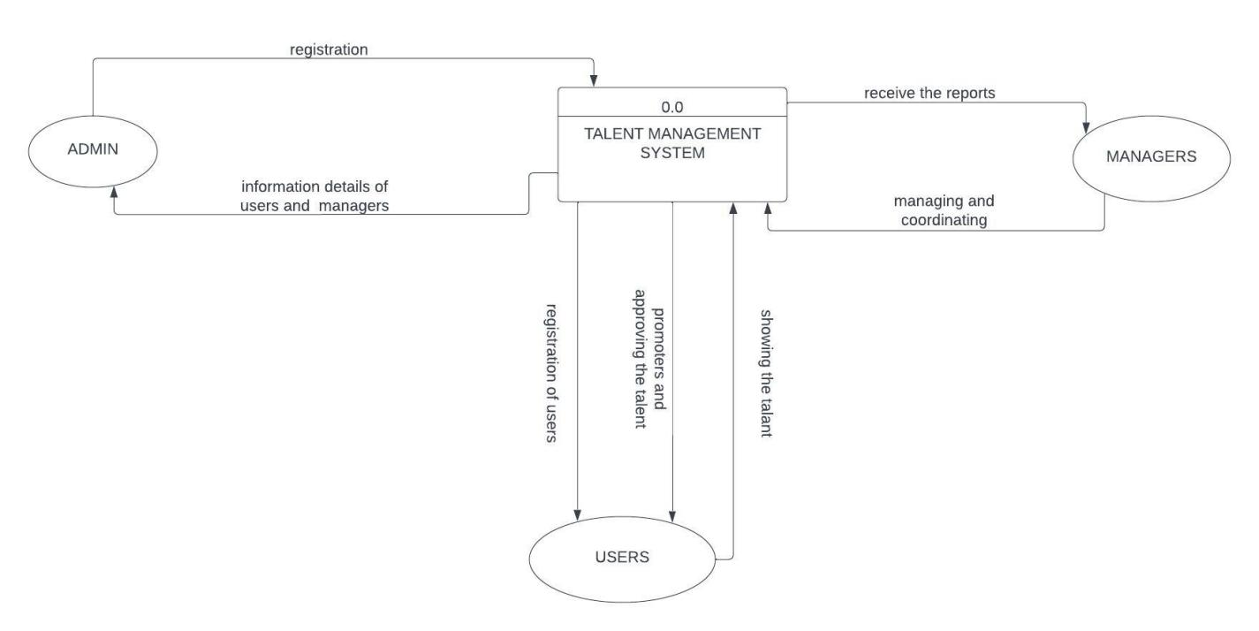

Figure 1

## DFD LEVEL 1

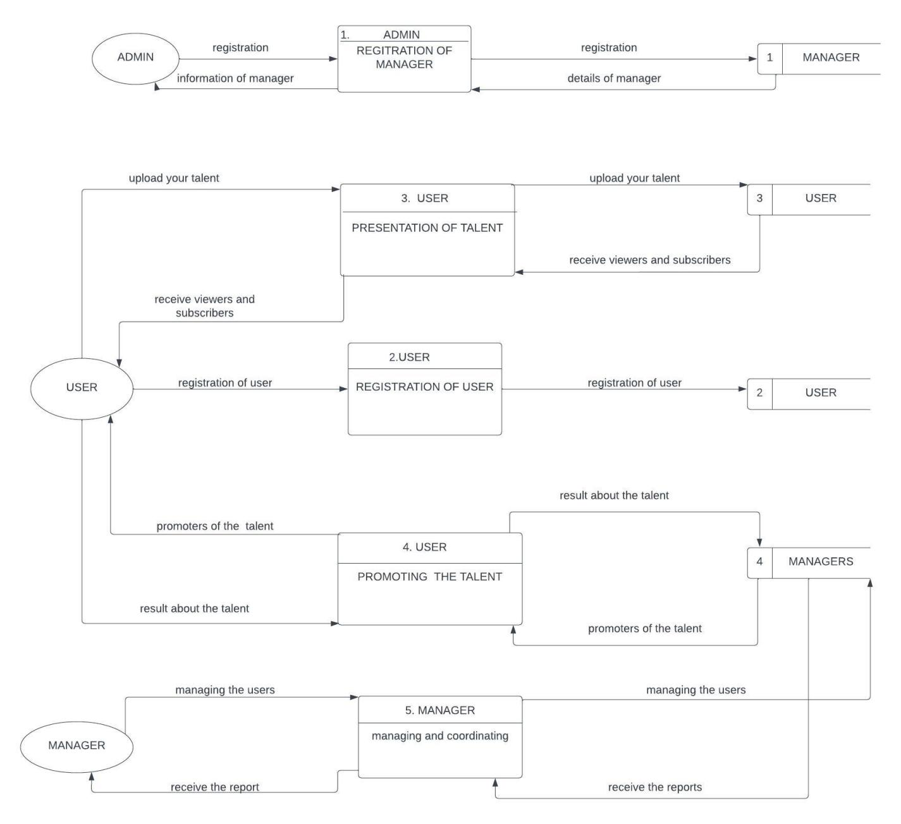

Figure 2

# Feasibility study

A feasibility study looks into an idea, project, or business's viability or sustainability. The research looks at whether there are sufficient resources to put it into practice and whether the idea has the potential to make profit. Additionally, it will highlight the rewards for taking the risk to invest in the concept.

A talent management system's viability and practicality for implementation within an organization are referred to as its feasibility. It entails determining the system's operational, financial, and technical viability. Feasibility analysis assists in determining whether the advantages of putting in place the talent management system outweigh the costs, risks, and difficulties involved.

## Technical Feasibility

This study evaluates whether talent management system can be successfully implemented from a

technical perspective. It assesses factors such as technical requirements, availability of resources, infrastructure, and expertise needed to execute the project.

A talent management system (TMS) is a software solution that helps organizations with talent acquisition, development, and retention. Assessing the technical feasibility of a TMS involves considering various factors:

System Requirements: Determine if the TMS meets your organization's technical requirements, such as operating systems, hardware specifications, and database compatibility. Ensure it can be deployed within your existing technology infrastructure.

Scalability: Consider if the TMS can accommodate your organization's growth. Evaluate if it can handle more users, employee records, and additional features without significant performance issues.

Integration: Assess the TMS's ability to integrate with other systems like HRIS, payroll, performance management, and learning management. Seamless data flow is crucial for effective talent management.

Data Management: Evaluate how the TMS handles data storage, retrieval, and processing. Consider data backup, disaster recovery, privacy, and compliance with regulations like GDPR. Ensure robust data security measures are in place.

User Interface and Experience: Assess the TMS's UI and UX for intuitiveness, user-friendliness, and customization options. A well-designed interface enhances user adoption and productivity.

Mobile Compatibility: Determine if the TMS supports mobile access through responsive design or dedicated mobile apps. Mobile capabilities enable talent-related tasks on the go.

Reporting and Analytics: Evaluate the TMS's reporting and analytics capabilities. It should offer comprehensive and customizable reporting options, along with advanced analytics features for data-driven talent decisions.

Vendor Support and Updates: Consider the reputation and reliability of the TMS vendor, their technical support services, and their track record in providing updates and bug fixes. Regular updates are important for security, stability, and compatibility.

Training and Support: Assess the availability of training resources, documentation, and user support for the TMS. Adequate training and support ensure effective utilization of the system's features.

To assess the technical feasibility of a specific TMS, it is necessary to review its documentation, conduct a thorough analysis, and potentially consult with the vendor or technical experts.

It is necessary to review the TMS's documentation, perform a thorough analysis, and perhaps seek advice from the vendor or technical specialists in order to determine whether a particular TMS is technically feasible.

## Financial Feasibility

This study analyzes the financial aspects of the talent management system, including the estimated costs, potential revenues, return on investment (ROI), and profitability. It helps determine if the project is financially viable and if the expected benefits outweigh the costs.

Due to its potential to increase employee performance, boost retention rates, and spur business growth, talent management is financially viable. Talent management programs increase productivity and efficiency within organizations by locating and fostering the development of high-potential individuals. The costs and risks of hiring externally are reduced through effective succession planning and internal talent development. Additionally, encouraging a culture of lifelong learning and professional development can increase employee engagement and decrease turnover, which will save a lot of money on training and onboarding costs. Overall, by cultivating a skilled workforce, encouraging innovation, and positioning businesses for sustainable success, the strategic investment in talent management yields long-term financial benefits.

## Market Feasibility

This study focuses on the market potential and demand for the proposed product or service. It assesses factors such as target market size, competition, customer preferences, and potential market share. This analysis helps determine if there is a market need and if the project has the potential for success in the marketplace.

A talent management system has high market viability and is expanding. In order to stay competitive, businesses in all sectors understand how crucial it is to draw in, nurture, and keep top talent. The recruitment, onboarding, performance management, learning and development, and succession planning processes can all be streamlined with the help of talent management systems. The demand for digital talent management tools is further fueled by the growing use of technology in HR procedures and the move toward remote and flexible work arrangements. Additionally, these systems are valuable assets for organizations due to their capacity to deliver data-driven insights, enhance employee engagement, and improve decision-making. The viability of a well-designed and feature-rich talent management system remains strong given the market's focus on talent optimization.

## Economic Feasibility

This study evaluates the economic viability of the talent management system by considering factors such as the impact on the local economy, job creation, income generation, and overall economic benefits. It helps assess the project's contribution to the broader economy and its sustainability in the long term.

A talent management system's ability to generate value that outweighs the costs of its setup and maintenance determines whether it is economically feasible. Numerous advantages of such a system can boost the business's bottom line.

First off, a talent management system automates and streamlines various HR procedures, lowering overhead and enhancing operational effectiveness. It does away with the need for manual paperwork, streamlines hiring and onboarding of new employees, improves performance management, and makes succession planning easier. These advancements allow HR professionals to concentrate on strategic tasks while saving time and resources.

A talent management system also increases employee engagement and retention. Organizations can identify and develop high-potential employees, lowering turnover rates and associated recruitment costs, by offering tools for performance tracking, career development, and continuous feedback. Employee engagement increases productivity, which boosts output and efficiency.

Systems for managing talent also improve talent analytics and workforce planning. These systems offer data-driven insights into talent pools, skills gaps, and training requirements, empowering organizations to choose wisely when it comes to hiring, investing in training, and allocating resources. Planning strategically for your workforce can reduce labor costs, improve staffing levels, and align talent with organizational objectives.

Furthermore, compliance and risk management are supported by talent management systems. They make sure that laws, business rules, and data protection guidelines are followed. Organizations can prevent expensive legal problems and reputational harm by reducing the risk of non-compliance and the associated penalties.

In conclusion, a properly implemented talent management system can produce significant economic benefits, such as decreased administrative costs, improved employee retention, increased productivity, enhanced workforce planning, and better compliance. It gives businesses the ability to strategically manage their talent, ensuring that it is in line with their goals and, ultimately, generating profits.

## Legal and Regulatory Feasibility

This study examines the legal and regulatory requirements and constraints associated with the talent management system. It assesses if the talent management system complies with applicable laws, regulations, permits, licenses, and any potential legal or regulatory hurdles that may impact its implementation.

A talent management system is a piece of software created to help businesses manage their workforce more efficiently by automating a number of HR procedures like hiring, onboarding, performance management, learning and development, and succession planning. Several factors need to be taken into account when evaluating the legal and regulatory viability of implementing a talent management system.

Privacy and data protection: With the emphasis on data privacy becoming more and more important, organizations must make sure the talent management system complies with all relevant data protection laws. The proper safeguards should be in place to protect personal data and guarantee that consent is obtained when required.

Equal employment opportunity: Talent management programs need to adhere to laws that support equal employment opportunities. These programs shouldn't exclude applicants or workers based on protected traits like race, gender, age, religion, or disability.

Labor laws and regulations: Talent management systems should be in compliance with all applicable labor laws and regulations, including those governing the number of hours worked, overtime pay, the minimum wage, and employee classification. The system must support compliance with these laws and be able to produce accurate records for reporting requirements.

Intellectual property: Organizations must make sure they have the required rights or licenses to use any intellectual property, including proprietary algorithms, assessment tools, or other assets, if the talent management system calls for their use. To avoid improper use or infringement, they ought to also defend their own intellectual property rights.

Organizations must take security and confidentiality of the data stored in the talent management system into account. Sensitive employee data should be safeguarded against unauthorized access, data breaches, and other security incidents.

Local laws: Additional legal and regulatory requirements might be necessary depending on the country in which the talent management system is used. These may include particular labor laws, rules for a certain sector of the economy, or data protection laws specific to a particular nation. Organizations are required to ensure adherence to all pertinent laws in the jurisdictions in which they conduct business.

Organizations should include legal professionals and compliance officers during the implementation and customization of the talent management system to ensure legal and regulatory feasibility. To ensure adherence to relevant laws and regulations, a comprehensive review of the system's features and functionalities must be conducted. To keep up with changing legal requirements and reduce any potential risks, regular audits and updates should be carried out.

## Operational Feasibility

This study evaluates whether the project can be effectively integrated into existing operations and processes. It assesses factors such as the availability of necessary resources, workforce skills and training requirements, the potential impact on current operations, and any operational challenges that may arise.

A talent show management system's operational viability is determined by evaluating its usefulness and efficiency. Usability of the system, integration capabilities, performance and scalability, flexibility and customization, communication and collaboration, technical support and maintenance, and cost considerations are important elements. The system must be easy to use, work with current procedures, manage the anticipated workload, be adaptable, encourage communication and teamwork, offer technical support, and be affordable. Organizations can make wise decisions by evaluating these factors to see if the system can be implemented. Stakeholder involvement, pilot testing, and feedback gathering all help to improve operational feasibility and raise the likelihood of successful implementation.

# Description of the selected Process Model

The talent management process model is a cyclical process that includes the following stages:

Planning: This stage involves identifying the organization's talent needs, developing a talent management strategy, and setting goals.

Acquiring: This stage involves attracting, recruiting, and selecting the right talent for the organization.

Assessing: This stage involves evaluating employee performance, identifying talent gaps, and developing succession plans.

Developing: This stage involves providing employees with the training and development they need to succeed in their roles.

Deploying: This stage involves aligning employee goals with the organization's goals, providing career development opportunities, and managing employee performance.

Retaining: This stage involves creating a positive work environment, providing competitive compensation and benefits, and recognizing employee achievements.

The talent management process model is an important tool for organizations that want to attract, develop, and retain top talent. By following the steps in the model, organizations can ensure that they have the right people in the right roles, and that their employees are able to reach their full potential.

Here is a more detailed description of each stage of the talent management process model:

Planning:

Identify the organization's talent needs.

Develop a talent management strategy.

Set goals for the talent management process.

Acquiring:

Attract top talent.

Screen and select candidates.

Onboard new employees.

Assessing:

Evaluate employee performance.

Identify talent gaps.

Develop succession plans.

Developing:

Provide training and development opportunities.

Coach and mentor employees.

Support employee career development.

Deploying:

Align employee goals with the organization's goals.

Provide career development opportunities.

Manage employee performance.

Retaining:

Create a positive work environment.

Provide competitive compensation and benefits.

Recognize employee achievements.

The talent management process model is a dynamic process that should be continuously reviewed and updated to ensure that it is meeting the organization's needs. By following the steps in the model, organizations can ensure that they are effectively managing their talent and achieving their business goals.

## Cause of your selection

There are many factors that can influence the selection of a talent management system, including:

The size and complexity of the organization. Larger organizations with complex needs may require a more robust talent management system than smaller organizations.

The organization's budget. Talent management systems can range in price from a few thousand dollars to several hundred thousand dollars.

The organization's specific needs. Some organizations may need a system that focuses on recruiting and onboarding, while others may need a system that focuses on performance management and succession planning.

The organization's culture. Some organizations prefer a system that is easy to use and has a user-friendly interface, while others may prefer a system that is more customizable and can be integrated with other HR systems.

In addition to these factors, the selection of a talent management system may also be influenced by the following:

The recommendations of industry experts.

The reviews of other users.

The ease of implementation.

The level of support offered by the vendor.

The specific cause of your selection of a talent management system will depend on your organization's specific needs and requirements. However, by considering the factors listed above, you can make an informed decision about which system is right for you.

Here are some additional tips for selecting a talent management system:

Start by defining your needs. What are the specific goals you want to achieve with a talent management system?

Do your research. There are many different talent management systems on the market, so it's important to do your research and compare different options.

Get quotes from different vendors. Once you've narrowed down your options, get quotes from different vendors to compare prices and features.

Talk to other users. If you know any other organizations that use a talent management system, ask them about their experiences.

Make sure the system is easy to use. The system should be easy to use for both employees and administrators.

Make sure the system is secure. The system should have strong security features to protect your data.

By following these tips, you can select a talent management system that meets your organization's needs and helps you achieve your business goals.

# Conclusion

A talent management system (TMS) is a software application that helps organizations manage their talent. TMSs typically include modules for recruiting, onboarding, performance management, training and development, succession planning, and compensation.

TMSs can help organizations to:

Attract and retain top talent. By providing a centralized repository for job postings, TMSs can help organizations to attract top talent. They can also help organizations to track the progress of candidates through the recruiting process and to make informed hiring decisions.

Onboard new employees effectively. TMSs can help organizations to onboard new employees effectively by providing them with access to important information, such as company policies and procedures, and by tracking their progress through the onboarding process.

Manage performance effectively. TMSs can help organizations to manage performance effectively by providing a platform for setting goals, tracking performance, and providing feedback.

Provide training and development opportunities. TMSs can help organizations to provide training and development opportunities by providing a centralized repository for training courses and by tracking employee progress through training programs.

Plan for succession. TMSs can help organizations to plan for succession by identifying potential successors for key positions and by tracking their progress through development programs.

Compensation employees fairly. TMSs can help organizations to compensate employees fairly by providing a platform for tracking employee performance and by comparing employee salaries to market data.

TMSs can be a valuable tool for organizations that want to attract, develop, and retain top talent. However, it is important to choose a TMS that meets the specific needs of your organization.

Here are some of the benefits of using a talent management system:

Improved efficiency: TMSs can help to streamline and automate many of the tasks involved in talent management, such as recruiting, onboarding, and performance management. This can free up time for HR professionals to focus on other important tasks.

Increased visibility: TMSs can provide a central repository for all talent-related data, which can help to improve visibility into the workforce and identify areas for improvement.

Better decision-making: TMSs can provide insights into employee performance, skills, and development needs, which can help organizations to make better decisions about hiring, promotions, and training.

Enhanced employee engagement: TMSs can help to improve employee engagement by providing a platform for employees to track their own progress, set goals, and receive feedback.

Overall, a talent management system can be a valuable tool for organizations that want to improve their talent management processes and achieve their business goals.

# References

Sure, here are some references of talent management systems:

Workday: Workday is a cloud-based HCM suite that includes a talent management module. Workday's talent management module provides a centralized repository for talent-related data, such as employee profiles, performance reviews, and training records. It also includes features for recruiting, onboarding, performance management, and succession planning.

**Oracle HCM Cloud:** Oracle HCM Cloud is a cloud-based HCM suite that includes a talent management module. Oracle's talent management module provides a similar set of features to Workday's talent management module.

**SAP Success Factors:** SAP Success Factors is a cloud-based HCM suite that includes a talent management module. SAP's talent management module provides a similar set of features to Workday's and Oracle's talent management modules.

**PeopleSoft:** PeopleSoft is a traditional on-premises HCM suite that includes a talent management module. PeopleSoft's talent management module provides a similar set of features to the other talent management modules mentioned above.

**Bamboo HR:** Bamboo HR is a cloud-based HCM suite that is specifically designed for small and medium-sized businesses. Bamboo HR's talent management module provides a more basic set of features than the other talent management modules mentioned above.

<https://en.wikipedia.org/wiki/Got_Talent>

<https://www.dailymotion.com/dm_293d81a5ffae6445d3db20aa26ed6c89>

<https://youtube.fandom.com/wiki/Got_Talent_Global>

<https://www.freetv-app.com/channels/got-talent-global-playlist-26866189>

**DATABASE PROJECT**

**Section I**

**1. Describe all the entities and their corresponding attributes that are in your database.**

**Applicant: This entity represents an individual who has applied for a job opening. The attributes of this entity may include applicant ID, name, contact information, resume, cover letter, and application status.**

**Recruitment: This entity represents the process of hiring new employees. The attributes of this entity may include job requisition number, recruiting source, interview notes, and offer letter.**

**Performance review: This entity represents the process of evaluating employee performance. The attributes of this entity may include performance goals, ratings, and feedback.**

**Employee: This entity represents an individual employee. The attributes of this entity may include employee ID, name, contact information, job title, department, date of hire, education, skills, and experience.**

**Job: This entity represents a job opening in the organization. The attributes of this job may include job title, department, location, responsibilities, qualifications, and salary range.**

**2. Create an LDM of your entities**

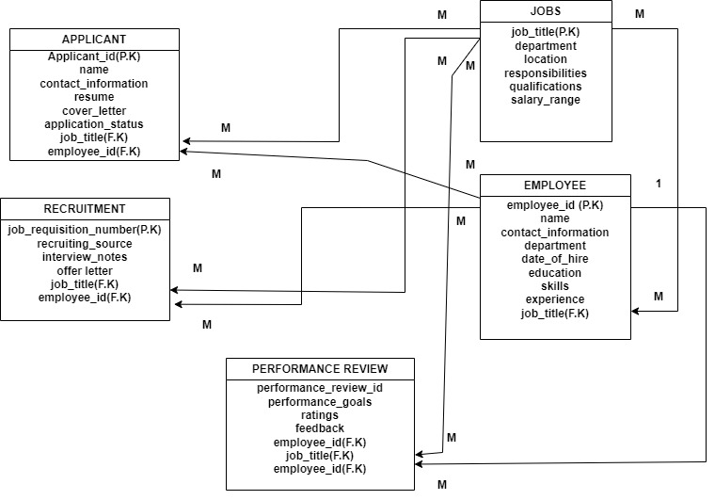

**3. Create an ERD**

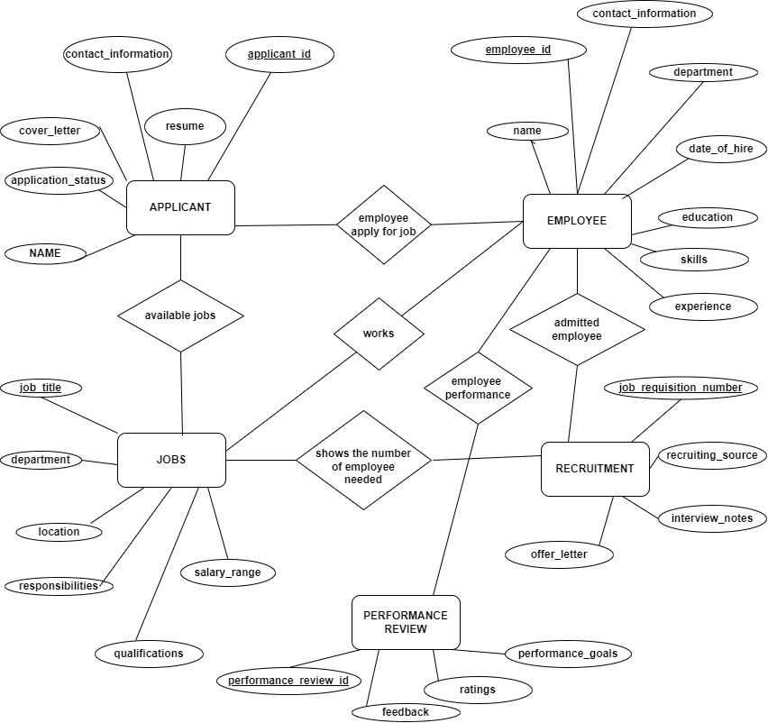

**Section II SQL**

**1. Create the database of your system**

**CREATE DATABASE TALENT_MANAGEMENT_SYSTEM;**

**2. Write queries to create all the tables and relationships of your system**

**CREATE TABLE employees (**

**employee_id INT NOT NULL AUTO_INCREMENT,**

**name VARCHAR(255) NOT NULL,**

**contact_information VARCHAR(255) NOT NULL,**

**job_title VARCHAR(255) NOT NULL,**

**department VARCHAR(255) NOT NULL,**

**date_of_hire DATE NOT NULL,**

**education VARCHAR(255) NOT NULL,**

**skills VARCHAR(255) NOT NULL,**

**experience VARCHAR(255) NOT NULL,**

**PRIMARY KEY (employee_id)**

**);**

**CREATE TABLE jobs (**

**job_title VARCHAR(255) NOT NULL,**

**department VARCHAR(255) NOT NULL,**

**location VARCHAR(255) NOT NULL,**

**responsibilities VARCHAR(255) NOT NULL,**

**qualifications VARCHAR(255) NOT NULL,**

**salary_range INT NOT NULL,**

**PRIMARY KEY (job_title)**

**);**

**CREATE TABLE applicants (**

**applicant_id INT NOT NULL AUTO_INCREMENT,**

**name VARCHAR(255) NOT NULL,**

**contact_information VARCHAR(255) NOT NULL,**

**resume VARCHAR(255) NOT NULL,**

**cover_letter VARCHAR(255) NOT NULL,**

**application_status VARCHAR(255) NOT NULL,**

**PRIMARY KEY (applicant_id)**

**);**

**CREATE TABLE recruitments (**

**job_requisition_number INT NOT NULL AUTO_INCREMENT,**

**recruiting_source VARCHAR(255) NOT NULL,**

**interview_notes VARCHAR(255) NOT NULL,**

**offer_letter VARCHAR(255) NOT NULL,**

**PRIMARY KEY (job_requisition_number)**

**);**

**CREATE TABLE performance_reviews (**

**performance_review_id INT NOT NULL AUTO_INCREMENT,**

**employee_id INT NOT NULL,**

**job_title VARCHAR(255) NOT NULL,**

**performance_goals VARCHAR(255) NOT NULL,**

**ratings VARCHAR(255) NOT NULL,**

**feedback VARCHAR(255) NOT NULL,**

**PRIMARY KEY (performance_review_id),**

**FOREIGN KEY (employee_id) REFERENCES employees (employee_id)**

**);**

**ALTER TABLE performance_reviews**

**ADD CONSTRAINT fk_performance_reviews_job_title**

**FOREIGN KEY (job_title) REFERENCES jobs (job_title);**

**3. write queries to insert data into your tables.**

**INSERT INTO employees (name, contact_information, job_title, department, date_of_hire, education, skills, experience)**

**VALUES ('John Doe', 'john.doe@email.com', 'Software Engineer', 'Engineering', '2023-03-08', 'BS in Computer Science', 'Java, Python, SQL', '3 years');**

**INSERT INTO jobs (job_title, department, location, responsibilities, qualifications, salary_range)**

**VALUES ('Software Engineer', 'Engineering', 'Kigali, Rwanda', 'Design, develop, and test software applications', 'BS in Computer Science', 'USD 50,000 - 100,000');**

**INSERT INTO applicants (name, contact_information, resume, cover_letter, application_status)**

**VALUES ('Jane Doe', 'jane.doe@email.com', 'resume.pdf', 'cover_letter.pdf', 'Pending');**

**INSERT INTO recruitments (job_requisition_number, recruiting_source, interview_notes, offer_letter)**

**VALUES (123456, 'LinkedIn', 'Good candidate, but not the best fit for the role', NULL);**

**INSERT INTO performance_reviews (employee_id, job_title, performance_goals, ratings, feedback)**

**VALUES (1, 'Software Engineer', 'Meet all deadlines, maintain high code quality, and work well with others', 'Excellent', 'Great job!');**

**4. Write queries to display all the information in your tables.**

**SELECT * FROM employees;**

**SELECT * FROM jobs;**

**SELECT * FROM applicants;**

**SELECT * FROM recruitments;**

**SELECT * FROM performance_reviews;**

**5. Write a query to update information in any of the two tables of your system**

**UPDATE employees**

**SET job_title = 'Senior Software Engineer'**

**WHERE employee_id = 1;**

**UPDATE employees**

**SET job_title = 'Senior Software Engineer',**

**department = 'Engineering'**

**WHERE employee_id = 1;**

**Section III**

**1. Create a view to insert data into your tables.**

**CREATE VIEW all_employees AS**

**SELECT \***

**FROM employees;**

**INSERT INTO all_employees (name, job_title, department)**

**VALUES ('Jane Doe', 'Software Engineer', 'Engineering');**

**CREATE VIEW insert_job AS**

**SELECT * FROM jobs;**

**INSERT INTO insert_job (job_title, department, location, responsibilities, qualifications, salary_range)**

**VALUES ('Software Engineer', 'Engineering', 'Kigali, Rwanda', 'Design, develop, and test software applications', 'BS in Computer Science', 'USD 50,000 - 100,000');**

**CREATE VIEW insert_performance_review AS**

**SELECT employee_id,**

**job_title,**

**performance_goals,**

**ratings,**

**feedback**

**FROM performance_reviews;**

**INSERT INTO insert_performance_review (employee_id, job_title, performance_goals, ratings, feedback)**

**VALUES (1, 'Software Engineer', 'Meet all deadlines, maintain high code quality, and work well with others', 'Excellent', 'Great job!');**

**CREATE VIEW applicant_review_view AS**

**SELECT applicant_id, name, contact_information, resume, cover_letter, application_status,**

**(SELECT job_title FROM jobs WHERE job_title = applicant_review.job_title) AS job_title,**

**(SELECT performance_goals FROM performance_reviews WHERE performance_reviews.employee_id = applicant_review.applicant_id) AS performance_goals,**

**(SELECT ratings FROM performance_reviews WHERE performance_reviews.employee_id = applicant_review.applicant_id) AS ratings,**

**(SELECT feedback FROM performance_reviews WHERE performance_reviews.employee_id = applicant_review.applicant_id) AS feedback**

**FROM applicants applicant_review;**

**INSERT INTO performance_reviews (employee_id, job_title, performance_goals, ratings, feedback)**

**SELECT 1, (SELECT job_title FROM applicants WHERE applicant_id = 1), 'Meet all deadlines, maintain high code quality, and work well with others', 'Excellent', 'Great job!'**

**FROM applicant_review_view;**

**2. Create a view to display all the information in your tables.**

**CREATE VIEW all_info_view AS**

**SELECT \***

**FROM employees**

**UNION ALL**

**SELECT \***

**FROM jobs**

**UNION ALL**

**SELECT \***

**FROM applicants**

**UNION ALL**

**SELECT \***

**FROM recruitments**

**UNION ALL**

**SELECT \***

**FROM performance_reviews;**

**3. Create a view to update information in any of the two tables of your system.**

**CREATE OR REPLACE VIEW updatable_employee_info AS**

**SELECT employee_id, First_name, Last_name, phone_number, email, location**

**FROM employee;**

**UPDATE updatable_employee_info**

**SET name=’john doe'**

**WHERE lcation=’kigali’;**

**CREATE OR REPLACE VIEW updatable_applicant_info AS**

**SELECT applicant_id, name,contact_information,resume**

**FROM applicant;**

**UPDATE updatable_applicant_info**

**SET name='Jane Doe'**

**WHERE applicant_id=’01’;**

**4. Create a view to delete data in any two of your tables according to any simple condition of your choice.**

**CREATE VIEW delete_data_view AS**

**SELECT \***

**FROM employees**

**WHERE department = 'Engineering';**

**DELETE FROM performance_reviews**

**WHERE employee_id IN (SELECT id FROM delete_data_view);**

**CREATE VIEW delete_applicant_view AS**

**SELECT applicant_id**

**FROM applicants**

**WHERE application_status = 'Rejected';**

**5. In your database, create one view of your choice that considers sub-query.**

**CREATE VIEW applicants_with_high_salary_view AS**

**SELECT applicant_id, name, contact_information, resume, cover_letter, application_status, salary**

**FROM applicants**

**WHERE salary > (SELECT AVG(salary) FROM applicants);**

**Section IV**

**1. Create a stored procedure to insert data into your tables.**

**CREATE PROCEDURE insert_employee (**

**IN employee_name VARCHAR(255),**

**IN contact_information VARCHAR(255),**

**IN job_title VARCHAR(255),**

**IN department VARCHAR(255),**

**IN date_of_hire DATE,**

**IN education VARCHAR(255),**

**IN skills VARCHAR(255),**

**IN experience VARCHAR(255)**

**)**

**BEGIN**

**INSERT INTO employees (name, contact_information, job_title, department, date_of_hire, education, skills, experience)**

**VALUES (employee_name, contact_information, job_title, department, date_of_hire, education, skills, experience);**

**END;**

**2. Create a stored procedure to display all the information in your tables.**

**CREATE PROCEDURE show_all_employees ()**

**BEGIN**

**SELECT \***

**FROM employees;**

**END;**

**3. Create a stored procedure to update information in any of the two tables of your system.**

**CREATE PROCEDURE update_employee (**

**IN employee_id INT,**

**IN employee_name VARCHAR(255),**

**IN contact_information VARCHAR(255),**

**IN job_title VARCHAR(255),**

**IN department VARCHAR(255),**

**IN date_of_hire DATE,**

**IN education VARCHAR(255),**

**IN skills VARCHAR(255),**

**IN experience VARCHAR(255)**

**)**

**BEGIN**

**UPDATE employees**

**SET name = employee_name,**

**contact_information = contact_information,**

**job_title = job_title,**

**department = department,**

**date_of_hire = date_of_hire,**

**education = education,**

**skills = skills,**

**experience = experience**

**WHERE employee_id = employee_id;**

**END;**

**4. Create a stored procedure to delete data in any two of your tables according to any simple condition of your choice.**

**CREATE PROCEDURE update_employee (**

**IN employee_id INT,**

**IN employee_name VARCHAR(255),**

**IN contact_information VARCHAR(255),**

**IN job_title VARCHAR(255),**

**IN department VARCHAR(255),**

**IN date_of_hire DATE,**

**IN education VARCHAR(255),**

**IN skills VARCHAR(255),**

**IN experience VARCHAR(255)**

**)**

**BEGIN**

**UPDATE employees**

**SET name = employee_name,**

**contact_information = contact_information,**

**job_title = job_title,**

**department = department,**

**date_of_hire = date_of_hire,**

**education = education,**

**skills = skills,**

**experience = experience**

**WHERE employee_id = employee_id;**

**END;**

**5. In your database, stored the procedure view of your choice that considers sub-query**

**CREATE PROCEDURE get_applicants_with_high_salary ()**

**BEGIN**

**SELECT \***

**FROM applicants**

**WHERE salary > (**

**SELECT AVG(salary)**

**FROM applicants**

**);**

**END;**

**Section V**

**1. Create after inserting triggers for any two tables of your choice.**

**-CREATE TRIGGER after_insert_trigger**

**AFTER INSERT ON applicants**

**FOR EACH ROW**

**BEGIN**

**INSERT INTO recruitments (applicant_id, job_title)**

**VALUES (NEW.applicant_id, NEW.job_title);**

**END;**

**-CREATE TRIGGER after_insert_job**

**AFTER INSERT ON jobs**

**FOR EACH ROW**

**BEGIN**

**INSERT INTO job_log (job_id, job_title, department, description, created_at, updated_at)**

**VALUES (NEW.job_id, NEW.job_title, NEW.department, NEW.description, NEW.created_at, NEW.updated_at);**

**END;**

**2. Create after-update triggers for any two tables of your choice.**

**-CREATE TRIGGER after_update_job_salary**

**AFTER UPDATE ON jobs**

**FOR EACH ROW**

**BEGIN**

**IF NEW.salary > OLD.salary THEN**

**INSERT INTO salary_increase_log (job_id, old_salary, new_salary, updated_at)**

**VALUES (NEW.job_id, OLD.salary, NEW.salary, NOW());**

**END IF;**

**END;**

**-** **CREATE TRIGGER after_update_job_and_applicant**

**AFTER UPDATE ON jobs, applicants**

**FOR EACH ROW**

**BEGIN**

**IF NEW.job_title != OLD.job_title THEN**

**UPDATE applicants**

**SET job_title = NEW.job_title**

**WHERE job_id = NEW.job_id;**

**END IF;**

**END;**

**3. Create after deleting triggers for any two tables of your choice**

**-CREATE TRIGGER after_delete_job_and_applicant**

**AFTER DELETE ON jobs, applicants**

**FOR EACH ROW**

**BEGIN**

**INSERT INTO deleted_jobs (job_id, job_title, department, description, created_at, updated_at)**

**VALUES (OLD.job_id, OLD.job_title, OLD.department, OLD.description, OLD.created_at, OLD.updated_at);**

**INSERT INTO deleted_applicants (applicant_id, name, contact_information, resume, cover_letter, application_status, job_id)**

**VALUES (OLD.applicant_id, OLD.name, OLD.contact_information, OLD.resume, OLD.cover_letter, OLD.application_status, OLD.job_id);**

**END;**

**Section VI**

**1. Create a user with your name as username and your student number as password and grant all privileges to the created user.**

**mysql -u root -p**

**create user 'nyangomaannet'@'localhost'IDENTIFIED BY '222001557';**

**GRANT ALL PRIVILEGES ON *.* TO 'nyangomaannet'@'localhost';**

**FLUSH PRIVILEGES;**

**exit;**

**2. Create a user with your "names_semi" as username and your student number as password and give him insert, update, and delete privileges to the created user.**

**mysql -u root -p**

**CREATE USER 'nyangoma'@'localhost' IDENTIFIED BY '222001557';**

**GRANT INSERT, UPDATE, DELETE ON *.* TO 'nyangoma'@'localhost';**

**FLUSH PRIVILEGES;**

**exit;**

**3. Revoke insert privileges to the last user you created**

**mysql -u root -p**

**REVOKE INSERT ON *.* FROM 'nyangoma'@'localhost';**

**FLUSH PRIVILEGES;**

**exit;**

**JAVA PROGRAMMING**

**A talent management system in Java would typically involve several key components and functionalities to effectively manage talent within an organization. Here's a general overview of how it might work:**

**1. User Authentication and Authorization:The system would have a login mechanism to authenticate users (employees, managers, HR) and provide them with appropriate access levels based on their roles.**

**2. Employee Database: The system would maintain a database of employee profiles, including personal information, job details, skills, and performance history.**

**3. Recruitment and Onboarding: It would support the recruitment process by allowing HR to post job openings, review applications, schedule interviews, and manage the onboarding process for new hires.**

**4. Performance Management: The system would track employee performance through regular evaluations, goal setting, and feedback mechanisms. It may also include features for performance improvement plans and recognition programs.**

**5. Training and Development:The system would facilitate employee training and development by providing access to learning resources, tracking training progress, and managing certifications.**

**6. Succession Planning:It would help in identifying and developing internal talent for key roles, ensuring a smooth transition when vacancies occur.**

**7. Analytics and Reporting: The system would generate reports and analytics on various talent management metrics, such as employee turnover, performance ratings, training effectiveness, etc., to help managers make informed decisions.**

**8. Integration with Other Systems: It may integrate with other systems such as payroll, HRIS (Human Resources Information System), or ERP (Enterprise Resource Planning) for seamless data flow and automation of processes.**

**Overall, the talent management system would aim to streamline HR processes, improve employee engagement and retention, and enable better decision-making regarding talent within the organization.**

**STEP 1**

**In a talent management system, a registration form plays a crucial role in onboarding new employees or registering existing employees for various activities within the system. Here are some key roles of a registration form in the project:**

**1. New Employee Onboarding:When a new employee joins the organization, they need to fill out a registration form to provide their personal details, contact information, emergency contacts, and other necessary information required for HR and payroll purposes.**

**2. Skill and Experience Information: The registration form can also include fields to capture the employee's skills, qualifications, work experience, certifications, and other relevant information that can help in talent management and career development planning.**

**3. Training and Development Registration: Employees can use the registration form to sign up for training programs, workshops, or courses offered by the organization. This helps HR and managers track employee development and training needs.**

**4. Performance Evaluation Registration:For performance evaluations, employees may need to register their goals, achievements, and self-assessment, which can be done through the registration form.**

**5. Event Registration:The form can be used to register employees for company events, team-building activities, or other corporate gatherings, helping in managing attendance and logistics.**

**6. Policy Acknowledgment:Employees can acknowledge their understanding and acceptance of company policies and guidelines through the registration form, ensuring compliance and accountability.**

**7. Data Collection for Reporting and Analytics: Information collected through the registration form can be used for generating reports and analytics on employee demographics, skills inventory, training needs, and other metrics important for talent management.**

**Overall, the registration form serves as a crucial tool for gathering essential information from employees, facilitating various HR processes, and supporting talent management initiatives within the organization.**

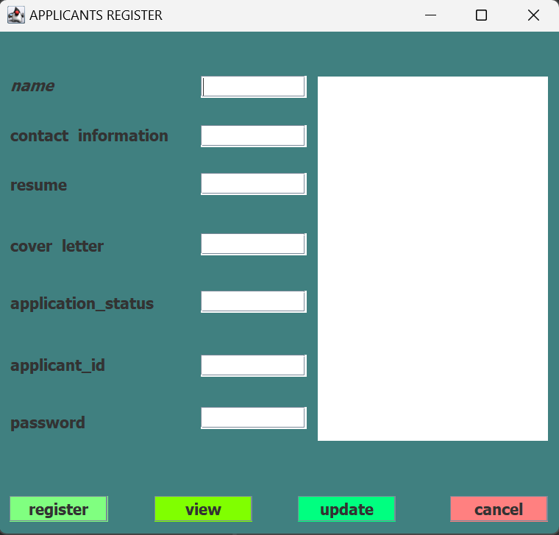

**STEP 2**

**In a talent management system, the login functionality plays a critical role in ensuring secure access to the system and providing personalized experiences for users. Here's how the login feature can be implemented and its role in the project:**

**1. Secure Access:The login form requires users to enter their credentials (username and password) to access the system. This helps ensure that only authorized users can access sensitive information.**

**2. User Authentication:The system verifies the user's credentials against the database to authenticate their identity. If the credentials are valid, the user is granted access to the system.**

**3. Role-based Access Control:After successful authentication, the system determines the user's role (e.g., employee, manager, HR) and grants appropriate access permissions based on that role. This ensures that users can only access features and data relevant to their role.**

**4. Personalized Experience:The login functionality allows the system to provide a personalized experience for each user, such as displaying relevant information, notifications, and tasks based on their role and preferences.**

**5. Security Measures:The login feature can also include security measures such as password hashing, session management, and account lockout policies to protect against unauthorized access and security breaches.**

**Overall, the login functionality is essential for ensuring secure access to the talent management system, providing personalized experiences for users, and maintaining the integrity and security of the system.**

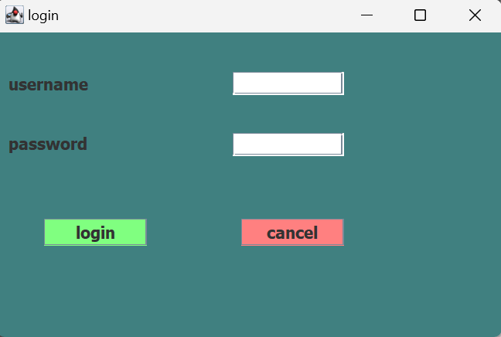

**STEP 3:**

**In your talent management system project, the dashboard form plays a crucial role in providing a visual representation of key metrics and information related to talent management. Here's how the dashboard form might work and its role in your project:**

**Key Metrics Display: The dashboard form can display important metrics such as employee performance ratings, training completion rates, turnover rates, and other relevant KPIs.**

**Graphical Representation: Graphs, charts, and visualizations can be used to present data in an easily understandable format, helping managers and HR professionals make informed decisions.**

**Quick Access to Information: The dashboard form can provide quick access to important information such as employee profiles, upcoming events, and notifications.**

**Customization: Users may be able to customize the dashboard to display the information most relevant to them, such as their team's performance or upcoming deadlines.**

**Data Drill-Down: Users can drill down into the data to get more detailed information or view historical trends, enabling better analysis and decision-making.**

**Integration with Other Modules: The dashboard form can be integrated with other modules of your talent management system, such as performance management, training, and recruitment, to provide a comprehensive view of talent-related activities.**

**Overall, the dashboard form in your project will serve as a centralized hub for monitoring and managing talent-related information, providing users with valuable insights and facilitating data-driven decision-making.**

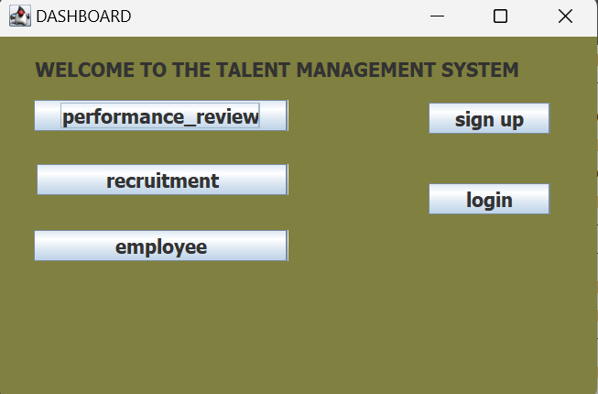

**STEP 4**

**In a talent management system, a performance review form is a key component used to assess an employee's performance over a specific period. Here's how it works and its role in the project:**

**Evaluation Criteria: The form typically includes predefined criteria or competencies that are used to evaluate the employee's performance. These criteria may vary depending on the organization's goals and values.**

**Self-Assessment: The form may include a section for the employee to provide a self-assessment of their performance, highlighting their achievements, challenges, and areas for improvement.**

**Manager Assessment: Managers use the form to evaluate the employee's performance based on the predefined criteria and provide feedback on their strengths, weaknesses, and areas for development.**

**Goal Setting: The form may also include a section for setting new goals or revising existing ones based on the performance review. This helps align the employee's objectives with the organization's goals.**

**Development Plan: Based on the performance review, a development plan may be created to help the employee improve their skills and performance. The form may include actions to be taken, resources required, and timelines for improvement.**

**Feedback and Comments: The form allows both the employee and the manager to provide feedback and comments, fostering open communication and collaboration.**

**Performance Rating: The form may include a rating scale or scoring system to quantify the employee's performance, which can be used for comparisons, promotions, or rewards.**

**Documentation: The completed form serves as a formal record of the performance review, which can be used for future reference, performance appraisals, and decision-making.**

**Overall, the performance review form is a critical tool for assessing and improving employee performance, setting goals, and fostering continuous learning and development within the organization.**

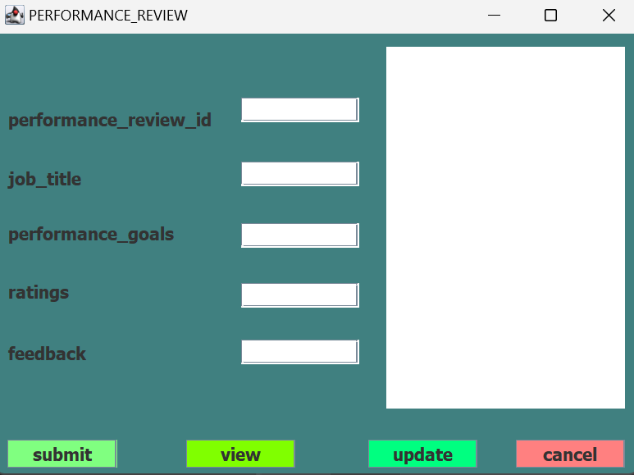

**STEP 5**

**In a talent management system, a recruitment form is used to collect information from job applicants during the hiring process. Here's how it works and its role in the project:**

**Job Posting and Application: The recruitment form is typically linked to job postings, allowing applicants to apply for specific positions by filling out the form.**

**Personal Information: The form collects basic personal information from applicants, such as name, contact details, and work authorization status.**

**Education and Work Experience: Applicants are asked to provide details about their education, including degrees, certifications, and institutions attended, as well as their work experience, including previous employers, job titles, and responsibilities.**

**Skills and Qualifications: The form may include fields for applicants to list their skills, qualifications, and any relevant certifications or licenses.**

**Cover Letter and Resume: Applicants are often required to upload a cover letter and resume, which are used to evaluate their qualifications and suitability for the position.**

**Availability and Salary Expectations: The form may include questions about the applicant's availability to start work and their salary expectations.**

**References: Applicants may be asked to provide references, including contact information for previous supervisors or colleagues who can vouch for their qualifications and work ethic.**

**Equal Employment Opportunity (EEO) Information: The form may include questions about the applicant's demographic information, such as race, gender, and ethnicity, for EEO reporting purposes. This information is typically optional and used for statistical analysis only.**

**Overall, the recruitment form plays a crucial role in collecting information from job applicants, screening candidates, and facilitating the hiring process within the organization.**

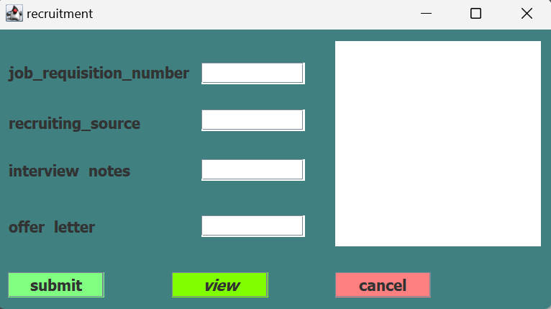

**STEP 6**

**In a talent management system, a job form is used to define and describe a job opening within an organization. Here's how it works and its role in the project:**

**Job Details: The form includes details about the job, such as the job title, department, location, and reporting structure. It also describes the responsibilities, duties, and requirements of the position.**

**Qualifications: The form specifies the qualifications and skills required for the job, including education, experience, certifications, and specific skills or competencies.**

**Salary and Benefits: The form may include information about the salary range, benefits package, and any other perks or incentives associated with the job.**

**Application Process: The form outlines the application process for the job, including how applicants should apply (e.g., through a recruitment form), the deadline for applications, and any specific instructions or requirements.**

**Job Posting: Once the job form is complete, it is used to create a job posting that is published internally or externally to attract potential candidates.**

**Approval Process: The form may include an approval process, where hiring managers or other stakeholders review and approve the job description before it is posted or finalized.**

**Tracking and Reporting: The form is used to track and report on the status of the job opening, including the number of applications received, the status of interviews, and the final hiring decision.**

**Overall, the job form plays a crucial role in defining and advertising job openings, attracting qualified candidates, and facilitating the hiring process within the organization.**

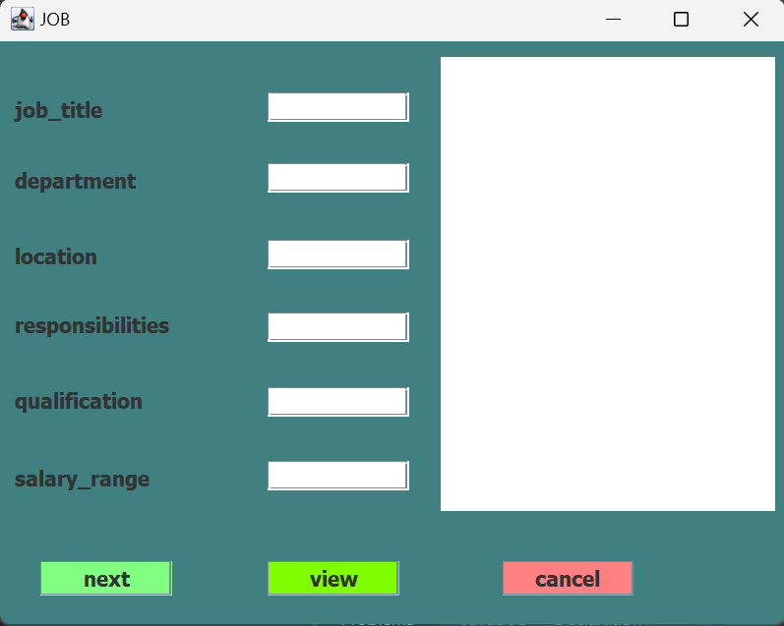

**STEP 7:**

**In a talent management system, an employee form is used to collect and manage information related to an employee's employment within the organization. Here's how it works and its role in the project:**

**Personal Information: The form collects basic personal information about the employee, such as name, address, contact details, and emergency contacts.**

**Employment Details: The form includes information about the employee's employment status, job title, department, manager, and start date. It may also include details about their compensation, benefits, and work schedule.**

**Performance Information: The form may include sections for tracking and evaluating the employee's performance, including performance reviews, goal setting, and feedback from managers and peers.**

**Training and Development: The form may include information about the employee's training and development activities, including courses attended, certifications obtained, and development goals.**

**Leave and Attendance: The form may include sections for tracking the employee's leave and attendance records, including vacation days taken, sick leave, and other absences.**

**Benefits and Compensation: The form may include details about the employee's benefits package, including health insurance, retirement plans, and other perks or incentives.**

**Employee Acknowledgment: The form may include sections where the employee acknowledges their understanding and acceptance of company policies, code of conduct, and other relevant documents.**

**Separation and Exit: If the employee leaves the organization, the form may be used to collect information about the reason for separation, return of company property, and other exit procedures.**

**Overall, the employee form plays a crucial role in managing employee information, tracking performance, facilitating training and development, and ensuring compliance with company policies and procedures.**

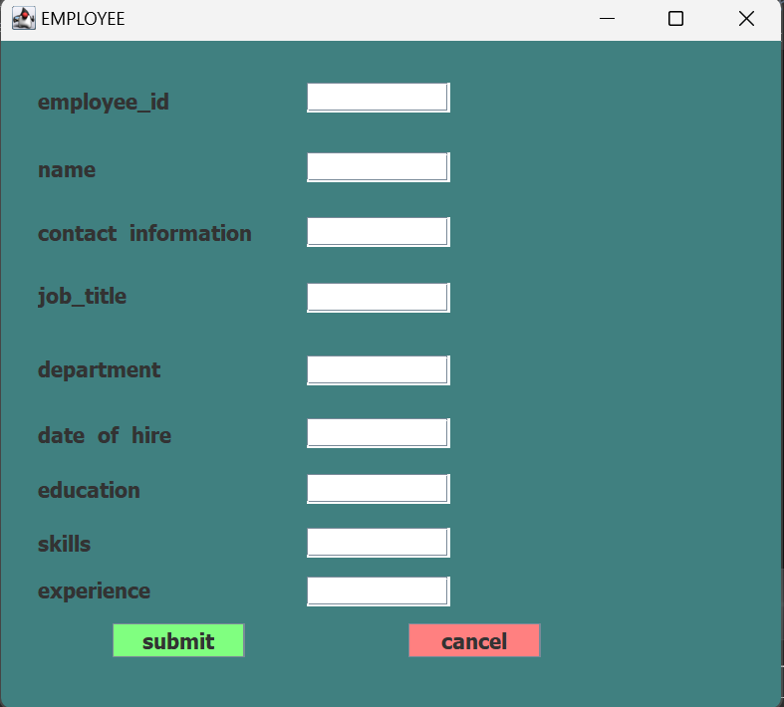

**In conclusion**

**A talent management system encompasses various forms, each serving a specific purpose in managing different aspects of talent within an organization. The registration form is crucial for onboarding and managing employee information, the login functionality ensures secure access to the system, the performance review form facilitates performance evaluation and goal setting, the recruitment form helps in collecting information from job applicants, the job form defines and describes job openings, and the employee form collects and manages information related to an employee's employment. Together, these forms play a vital role in streamlining HR processes, improving employee engagement and retention, and enabling better decision-making regarding talent management within the organization.**

**REFERENCES**

**Java Programming:**

**Oracle Java Tutorials: https://docs.oracle.com/javase/tutorial/**

**"Head First Java" by Kathy Sierra and Bert Bates**

**"Effective Java" by Joshua Bloch**

**Eclipse IDE:**

**Eclipse Documentation: https://help.eclipse.org/latest/index.jsp**

**"Eclipse IDE Pocket Guide" by Ed Burnette**

**Database Connectivity in Java:**

**JDBC Tutorial: https://www.tutorialspoint.com/jdbc/index.htm**

**"Java Database Best Practices" by George Reese, Pat Chou, and Victor Janulaitis**

**Java EE (Enterprise Edition):**

**Java EE Documentation: https://javaee.github.io/tutorial/toc.html**

**"Beginning Java EE 7" by Antonio Goncalves**

**Database (e.g., MySQL, PostgreSQL):**

**MySQL Documentation: https://dev.mysql.com/doc/**

**PostgreSQL Documentation: https://www.postgresql.org/docs/**

1.
2.